**WEEK 1 REFLECTION**

This week’s lab gave me the chance to gain hands-on experience with JavaScript by building a simple calculator that performs addition, subtraction, multiplication, and division of two or more numbers.

When I started, I was eager to apply what I knew about JavaScript syntax and concepts. Although I had a general understanding of how to implement basic arithmetic operations, translating that into working code was a challenge. My goal was to not only complete the required functionality but also strengthen my understanding of variables, functions, conditionals, and control flow in JavaScript.

Key Concepts Learned:

* Functions
* Arrays and Loops
* Error Handling
* Reflection on the Code:

The final calculator program works as expected, and it was rewarding to see basic arithmetic operations come together in functional code. This exercise helped solidify my understanding of JavaScript fundamentals like functions, conditionals, and loops, while also introducing me to handling arrays and performing operations on them.

Screenshot 🡪 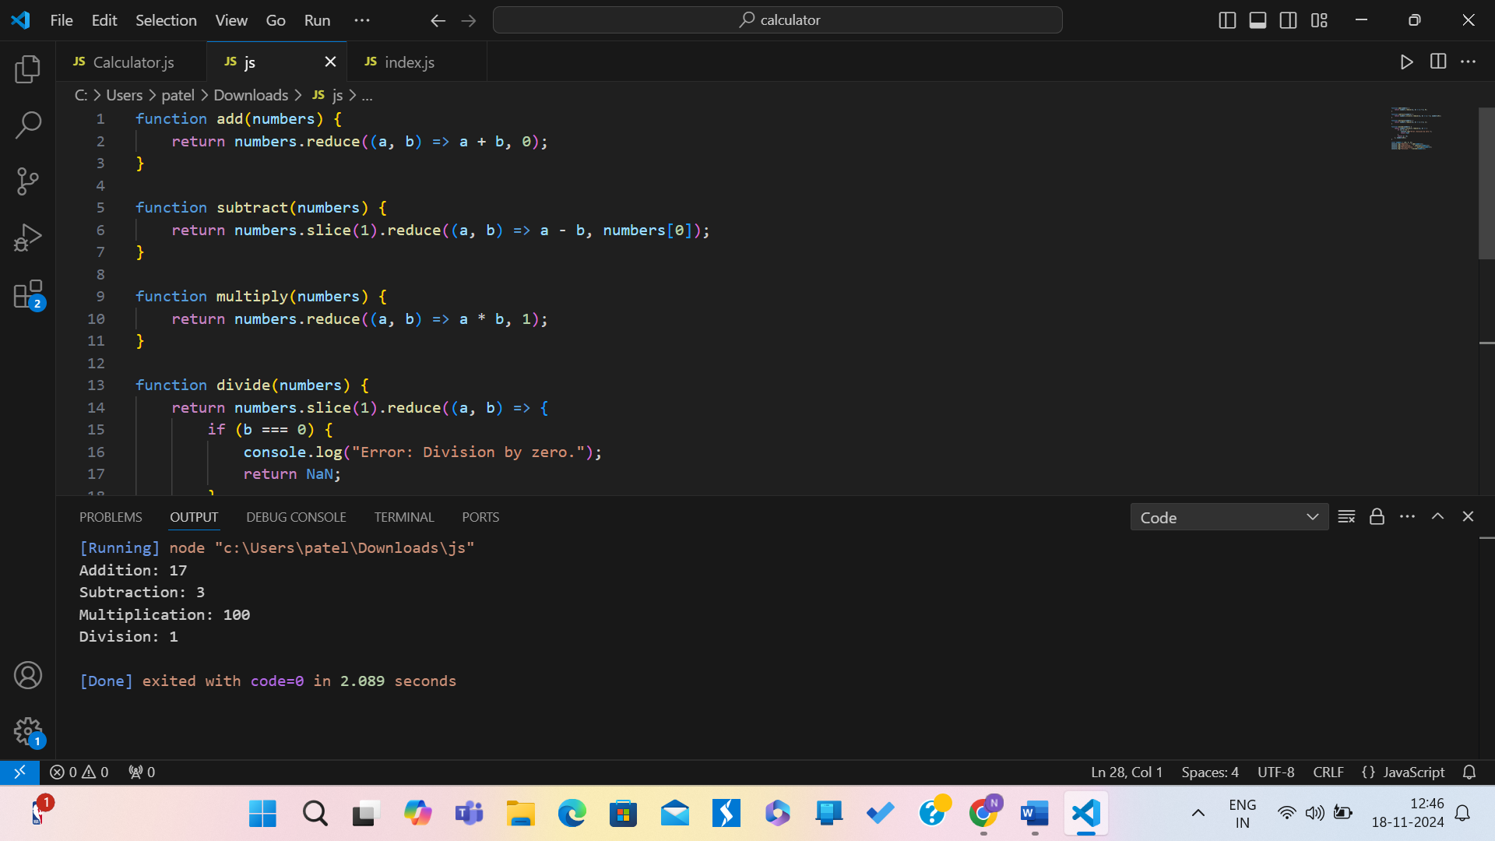

Code 🡪

function add(numbers) {

    return numbers.reduce((a, b) => a + b, 0);

}

function subtract(numbers) {

    return numbers.slice(1).reduce((a, b) => a - b, numbers[0]);

}

function multiply(numbers) {

    return numbers.reduce((a, b) => a * b, 1);

}

function divide(numbers) {

    return numbers.slice(1).reduce((a, b) => {

        if (b === 0) {

            console.log("Error: Division by zero.");

            return NaN;

        }

        return a / b;

    }, numbers[0]);

}

const numbers = [10, 5, 2];

console.log("Addition: " + add(numbers));

console.log("Subtraction: " + subtract(numbers));

console.log("Multiplication: " + multiply(numbers));

console.log("Division: " + divide(numbers));